RaspberryPI Config:
- Download - https://sourceforge.net/projects/win32diskimager/postdownload
- Follow these steps-
- Insert Working PI memory card inside card reader and load. Then follow this-
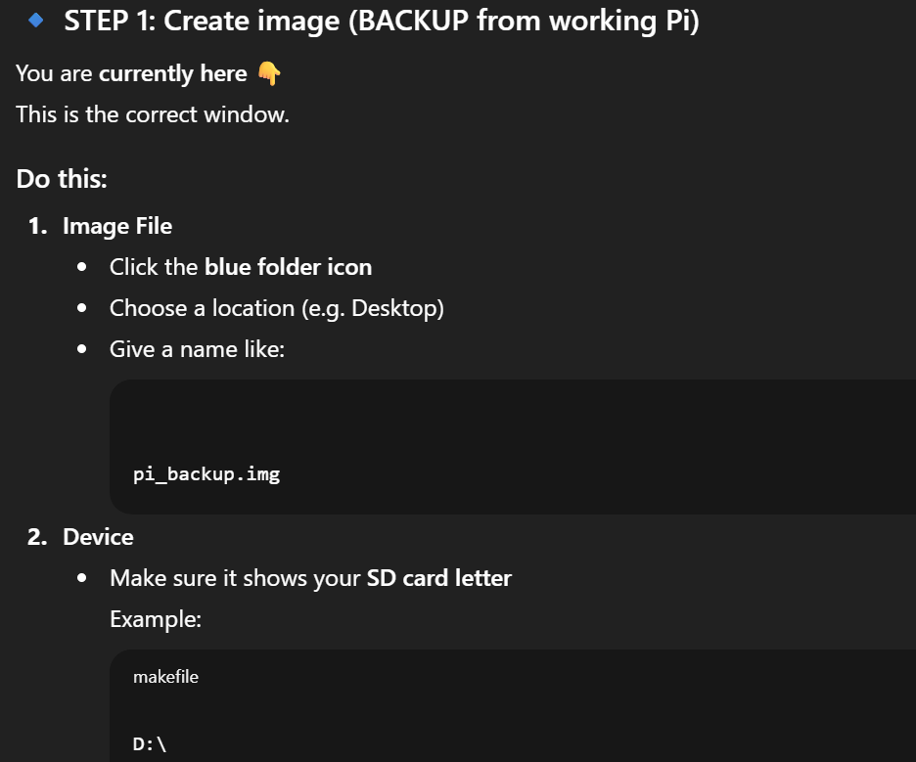
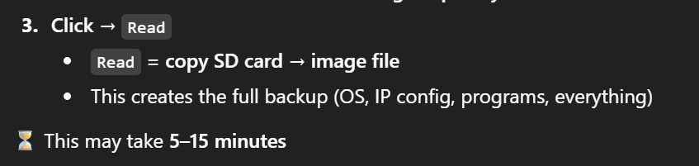
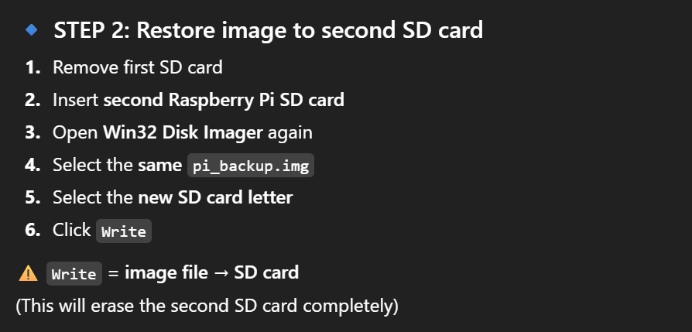

Windows Side Config:
- Camera IP address – 192.168.1.2
- Raspberry IP address – 192.168.1.3
- Windows IP address – 192.168.1.4

- Firewall: Yes (Disable)

Windows Ethernet Setting:
- Setting – Manual
- IP - 192.168.1.4
- Subnet – 24
- DNS – 8.8.8.8 (Optional)

